National Services Scotland  IT Division | National Service Scotland  Meridian Court  5 Cadogan Street  Glasgow  G2 6QE  Telephone 0141 282 2100  http://www.sci.scot.nhs.uk | 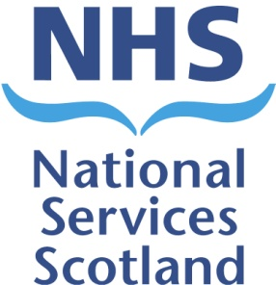

HIGH IMPORTANCE MESSAGE FOR THE R20 UPGRADE

This message is to highlight the complexity of the forthcoming SCI Gateway upgrade about to be effected on the weekend of 18th – 21st August 2017 and a potential impact arising from that complexity.

This is by far the most complex release the NSS IT teams have had to contend with in the 16 year history of SCI Gateway.

Normally, a release consists of major and minor changes to the SCI Gateway Application and the supporting access methods. This time however, not only are the usual Application changes being made, there are also changes to the underlying software that the Application runs on ie Windows and SQL versions; the hardware that supports the whole SCI Gateway infrastructure is moving from being completely made up from dedicated servers for all aspects of the Service, to a mixed environment of virtual and dedicated servers; this is all taking place within a new infrastructure that has introduced enhanced security methods. Essentially everything is new and different.

The reason for telling you this level of detail at this time, is to help you understand that, whilst all the testing that can be effected before the changes take place has been very successful, there are aspects of the changes being made that can only be emulated at present and will not be able to be tested completely until the new structures and components are fully in place. This ‘on the day’ testing aspect may introduce some delays that cannot be accounted for at this time, as the actual timings for successful upgrade will remain unknown until the point of switchover.

The NSS IT Teams have been working hard in conjunction with Atos colleagues and are relatively confident of the timings for the upgrade that have previously been notified ie Service withdrawal at 18:00 on Friday 18th August 2017 and Service restoration by Monday 0800 21st August 2017. However, as mentioned above, there is the potential for an unexpected delay to the Service being restored by 0800 on the 21st August 2017 and therefore NSS IT are informing Clinical colleagues, and other SCI Gateway Users, of a potential for delay to the commencement of the SCI Gateway Service on the 21st August 2017 and to enable you to put in place any contingency plans that you may wish to effect should any delays actually occur.

